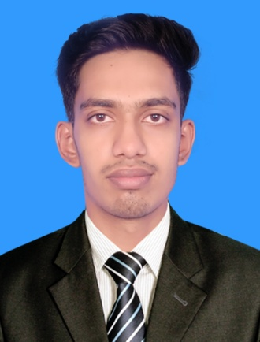

**CURRICULUM VITAE**

**MD. Mursidul Islam**

**Contact No: +880 175623-1188**

**E-mail: mursidulislam850@gmail.com**

**Address: Kalai, Joypurhat**

**Career Objective:**

Computer Science graduate with a strong foundation in programming and software development. Proficient in web technologies like HTML, CSS, Bootstrap and JavaScript.

Eager to apply academic knowledge in real-world software development projects. Quick learner with a passion for coding and building efficient solutions. Seeking an entry-level developer role to grow professionally and contribute to a dynamic team.

**Educational Qualification:**

**Diploma in Engineering**

**(Department: Computer Science and Technology)**

**2021-2025 “TMSS Textile Engineering Institute”**

Result: (Appeared) Average YGPA: ----- (out of 4) till 7th

Semester out of 8th semester.

**Higher Secondary School Certificate (HSC)**

**2022-2024 “Dhundar High School and Collage”**

Group: Science, GPA: 4.46, Board: Rajshahi

**Secondary School Certificate (SSC)**

**2016-2021 “Beala BL High School”**

Group: Science, GPA: 4.72, Board: Rajshahi

**Personal Information:**

Name : Md. Mursidul Islam

Father Name : Md. Saidur Rahman

Mother Name : Mst. Monowara begum

Permanent Address : Vill: Beala, Post: Matrai, upzila: Kalai, dist: Joypurhat

Date of Birth : 14th April2003

Nationality : Bangladeshi (by birth)

Marital Status : Unmarried

Height : 5 Feet 10 Inch

Blood Group : O+

Religion : Islam

**Computer Skills**

* MS Word, MS Excel, MS Power Point, MS Access, Internet etc.
* Web design and development (frontend)
* Adobe Photoshop, Adobe Illustrator, Graphics Design Basic Tools.
* HTML, CSS, Bootstrap, JavaScript etc.
* I have successfully completed Web Design and Development for Freelancing Level-3 Course from NACTAR.
* Language: Bangla, Hindi, English

**REFERENCE**

**Shahriyar Ahmmed**

Head teacher of

Computer Science and Technology

TMSS Textile Engineering Institute

Call: +880 1313092885



**Signature**

**(Md. Mursidul Islam)**